World War II (1939-1945)
17/04/07

Country | Leaders
Germany  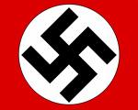 | -Adolf Hitler
Italy  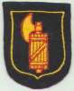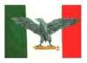 | -Benito Mussolini
Japan  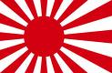 | -Emperor Hirohito  -Prime Minister Toji Hideki
Soviet Union (USSR)  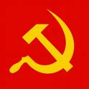 | -Josef Stalin (liked by Saddam Husayn)
Britain | -Prime Minister Chamberlain (1937-1940)  -Prime Minister Churchill (1940-1945)
USA | -President Franklin D. Roosevelt (1933-1945)  -President Harry S. Truman (1945-1953)
France | -Marshall Petain (Vichy France- collaborated with occupying German forces)  -Charles de Gaulle (leader of the Free French- in exile in Britain)
Canada | -Prime Minster W.L. Mackenzie King (1921-1926), (1926-1930), (1935-1948)
Note: dove foot = symbol of peace

